Non-Positional Numeral Systems
# Source: AI Source: Provided by: [Data Path: Persons Table -> ID Column: 1, Name_En Column: Motasem Essam] -> From: [ChatGPT] on [7/16/2026]
A Non-Positional Numeral System is a numeral system in which the value of each symbol is fixed and does not depend on its position within the numeral. Unlike positional systems, changing the order of symbols generally does not change their individual values, although the rules for combining symbols may affect the overall number.
Non-positional numeral systems were widely used in many ancient civilizations before the development of modern place-value systems.

Definition
# Source: AI Source: Provided by: [Data Path: Persons Table -> ID Column: 1, Name_En Column: Motasem Essam] -> From: [ChatGPT] on [7/16/2026]
A Non-Positional Numeral System is a numeral system in which each symbol has a fixed numerical value, regardless of its position in the numeral.
There is no place-value concept and no positional powers of a base.

Basic Principle
# Source: AI Source: Provided by: [Data Path: Persons Table -> ID Column: 1, Name_En Column: Motasem Essam] -> From: [ChatGPT] on [7/16/2026]
In a non-positional system:
- Every symbol has a fixed value.
- Position does not determine a symbol's value.
- Numbers are formed by combining symbols according to specific rules.
- Most non-positional systems do not have a true base (radix).

Characteristics
# Source: AI Source: Provided by: [Data Path: Persons Table -> ID Column: 1, Name_En Column: Motasem Essam] -> From: [ChatGPT] on [7/16/2026]
A non-positional numeral system:
- Does not use place value.
- Does not assign positional weights.
- Uses symbols with fixed values.
- Often requires many symbols for large numbers.
- Usually has more complicated arithmetic operations than positional systems.

Examples of Non-Positional Numeral Systems

Roman Numeral System
# Source: AI Source: Provided by: [Data Path: Persons Table -> ID Column: 1, Name_En Column: Motasem Essam] -> From: [ChatGPT] on [7/16/2026]
The Roman numeral system is the best-known non-positional numeral system.
Symbols
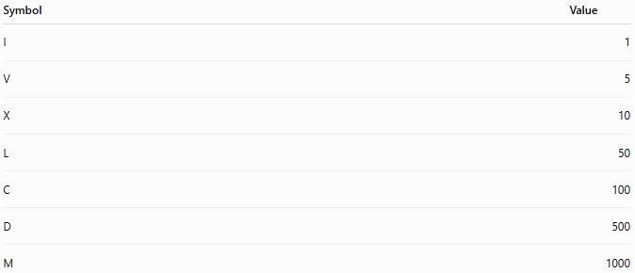
Symbol | Value
I | 1
V | 5
X | 10
L | 50
C | 100
D | 500
M | 1000
Example:
$$XII=10+1+1=12$$
Example:
$$IX=9$$
using the subtractive rule.

Egyptian Numeral System
# Source: AI Source: Provided by: [Data Path: Persons Table -> ID Column: 1, Name_En Column: Motasem Essam] -> From: [ChatGPT] on [7/16/2026]
Ancient Egyptian numerals used different symbols for powers of ten.
Each symbol represented a fixed value.
Numbers were formed by repeating symbols.
Example:
Three symbols representing 100 meant
$$300.$$

Greek Numeral System
# Source: AI Source: Provided by: [Data Path: Persons Table -> ID Column: 1, Name_En Column: Motasem Essam] -> From: [ChatGPT] on [7/16/2026]
Ancient Greek numerals assigned fixed values to alphabetic symbols.
Each letter represented a specific value regardless of position.

Hebrew Numeral System
# Source: AI Source: Provided by: [Data Path: Persons Table -> ID Column: 1, Name_En Column: Motasem Essam] -> From: [ChatGPT] on [7/16/2026]
Hebrew letters were assigned fixed numerical values.
Numbers were represented using combinations of letters.

Rules in Non-Positional Systems
# Source: AI Source: Provided by: [Data Path: Persons Table -> ID Column: 1, Name_En Column: Motasem Essam] -> From: [ChatGPT] on [7/16/2026]
Although position does not determine value, many systems use combination rules such as:

Repetition
# Source: AI Source: Provided by: [Data Path: Persons Table -> ID Column: 1, Name_En Column: Motasem Essam] -> From: [ChatGPT] on [7/16/2026]
Repeating a symbol adds its value.
Roman example:
$$III=3$$

Addition
# Source: AI Source: Provided by: [Data Path: Persons Table -> ID Column: 1, Name_En Column: Motasem Essam] -> From: [ChatGPT] on [7/16/2026]
Different symbols may be added.
Example:
$$VIII=5+1+1+1=8$$

Subtraction
# Source: AI Source: Provided by: [Data Path: Persons Table -> ID Column: 1, Name_En Column: Motasem Essam] -> From: [ChatGPT] on [7/16/2026]
Some systems allow subtraction.
Example:
$$IV=4$$
because
$$5-1=4.$$

Comparison with Positional Systems
# Source: AI Source: Provided by: [Data Path: Persons Table -> ID Column: 1, Name_En Column: Motasem Essam] -> From: [ChatGPT] on [7/16/2026]
In the decimal system
$$222$$
means
$$2×100+2×10+2=222.$$
The three digits have different values because of their positions.
In Roman numerals,
$$XXX=10+10+10=30.$$
Each X always represents 10.

Advantages
# Source: AI Source: Provided by: [Data Path: Persons Table -> ID Column: 1, Name_En Column: Motasem Essam] -> From: [ChatGPT] on [7/16/2026]
Non-positional systems:
- Simple for representing small numbers.
- Easy to read in ceremonial or historical contexts.
- Useful where arithmetic is not the primary purpose.
- Historically important.

Disadvantages
# Source: AI Source: Provided by: [Data Path: Persons Table -> ID Column: 1, Name_En Column: Motasem Essam] -> From: [ChatGPT] on [7/16/2026]
Non-positional systems:
- Inefficient for representing large numbers.
- Require many symbols.
- Make arithmetic operations difficult.
- Lack a place-value structure.
- Are unsuitable for modern computing.

Applications
# Source: AI Source: Provided by: [Data Path: Persons Table -> ID Column: 1, Name_En Column: Motasem Essam] -> From: [ChatGPT] on [7/16/2026]
Today, non-positional numeral systems are mainly used for:
- Historical documents
- Clock faces
- Book chapters
- Movie sequels
- Monarch names
- Religious texts
- Monument inscriptions
- Copyright years
- Event numbering

Real-Life Examples
# Source: AI Source: Provided by: [Data Path: Persons Table -> ID Column: 1, Name_En Column: Motasem Essam] -> From: [ChatGPT] on [7/16/2026]
Roman numerals are commonly used in:
- Clock faces
$$III, VI, IX, XII$$
- Olympic Games
- Super Bowl numbering
Example:
Super Bowl LVIII
- Book chapters
- Monarchs
Example:
King Charles III

Common Mistakes
# Source: AI Source: Provided by: [Data Path: Persons Table -> ID Column: 1, Name_En Column: Motasem Essam] -> From: [ChatGPT] on [7/16/2026]
- Thinking Roman numerals are positional.
- Assuming the value of a symbol changes with position.
- Trying to perform arithmetic using place-value methods.
- Believing all numeral systems have a base.

Key Points
# Source: AI Source: Provided by: [Data Path: Persons Table -> ID Column: 1, Name_En Column: Motasem Essam] -> From: [ChatGPT] on [7/16/2026]
- Symbol values are fixed.
- Position does not determine value.
- No place-value system exists.
- Roman numerals are the most common example.
- Most ancient numeral systems were non-positional.

Non-Positional vs. Positional Numeral Systems
# Source: AI Source: Provided by: [Data Path: Persons Table -> ID Column: 1, Name_En Column: Motasem Essam] -> From: [ChatGPT] on [7/16/2026]
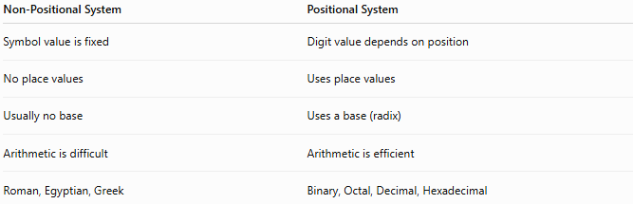
Non-Positional System | Positional System
Symbol value is fixed | Digit value depends on position
No place values | Uses place values
Usually no base | Uses a base (radix)
Arithmetic is difficult | Arithmetic is efficient
Roman, Egyptian, Greek | Binary, Octal, Decimal, Hexadecimal

Examples of Non-Positional Numeral Systems
# Source: AI Source: Provided by: [Data Path: Persons Table -> ID Column: 1, Name_En Column: Motasem Essam] -> From: [ChatGPT] on [7/16/2026]
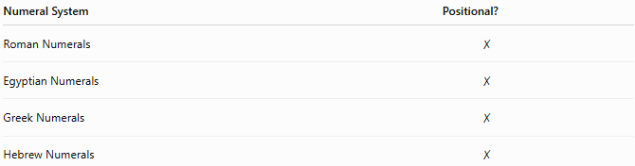
Numeral System | Positional?
Roman Numerals | ✗
Egyptian Numerals | ✗
Greek Numerals | ✗
Hebrew Numerals | ✗

Conclusion
# Source: AI Source: Provided by: [Data Path: Persons Table -> ID Column: 1, Name_En Column: Motasem Essam] -> From: [ChatGPT] on [7/16/2026]
A Non-Positional Numeral System is a numeral system in which each symbol has a fixed value regardless of its position. Unlike positional systems, it does not use place value or powers of a base. Numbers are formed by combining symbols according to specific rules such as addition, repetition, or subtraction. Although largely replaced by positional systems for mathematical and computational work, non-positional numeral systems remain historically significant and continue to be used in contexts such as Roman numerals on clocks, book chapters, monarch names, and ceremonial numbering.

